Recipes

You need to add 17 things to this document. (Make sure to number them just as I did in the example.) It may be helpful to copy and paste this list and then fill it in as you go along. All image names must start with your location, e.g yellowstone_sunset.jpg unless you are using a link from the internet.

1. Chicken Quesadilla
2. **Origin**: Mexican
3. **Source**: https://www.wellplated.com/chicken-quesadilla/
4. **Category**: Main Dish
5. 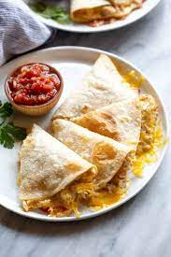
6. chicken quesadilla.jpg
7. A plain cheese quesadilla of the white tortilla + prebagged cheese + microwave-until-melted variety can be made a bit of a joke when describing someone’s ability to “cook,” but this juicy chicken quesadilla is well-above basic.
8. **Recipe Ingredients**
   1. Chicken
   2. Cheese
   3. Veggies
   4. Spices
   5. Hot sauce
   6. Whole wheat tortilla
   7. Toppings
9. **Recipe Steps – Just write Recipe Steps**
   1. Add the chicken to a bowl, then stir in half of the spices.
   2. Sauté the vegetables with spices.
   3. Assemble the quesadillas by piling the fillings onto one half of a tortilla.
   4. Fold the empty tortilla half over the top. Repeat.
   5. Cook the quesadillas two at a time in a skillet.
   6. Flip after about 4 minutes, cooking on the other side for a few minutes. Let cool, slice, and DIG IN!
10. **Additional Food images**

For the next three pictures you can just put the names of the files, you don't have to include the files in this drive, but you do need to add them to the proper Google Drive.

1. folded tortilla.jpg
2. Folded tortilla on a plate
3. File name
4. Visual description of the image/movie
5. file name
6. Visual description of the image/movie
7. Serena Shen
8. Double Chocolate Cookies
9. **Origin**: Michigan
10. **Source**: Family Recipe
11. **Category**: Dessert
12. 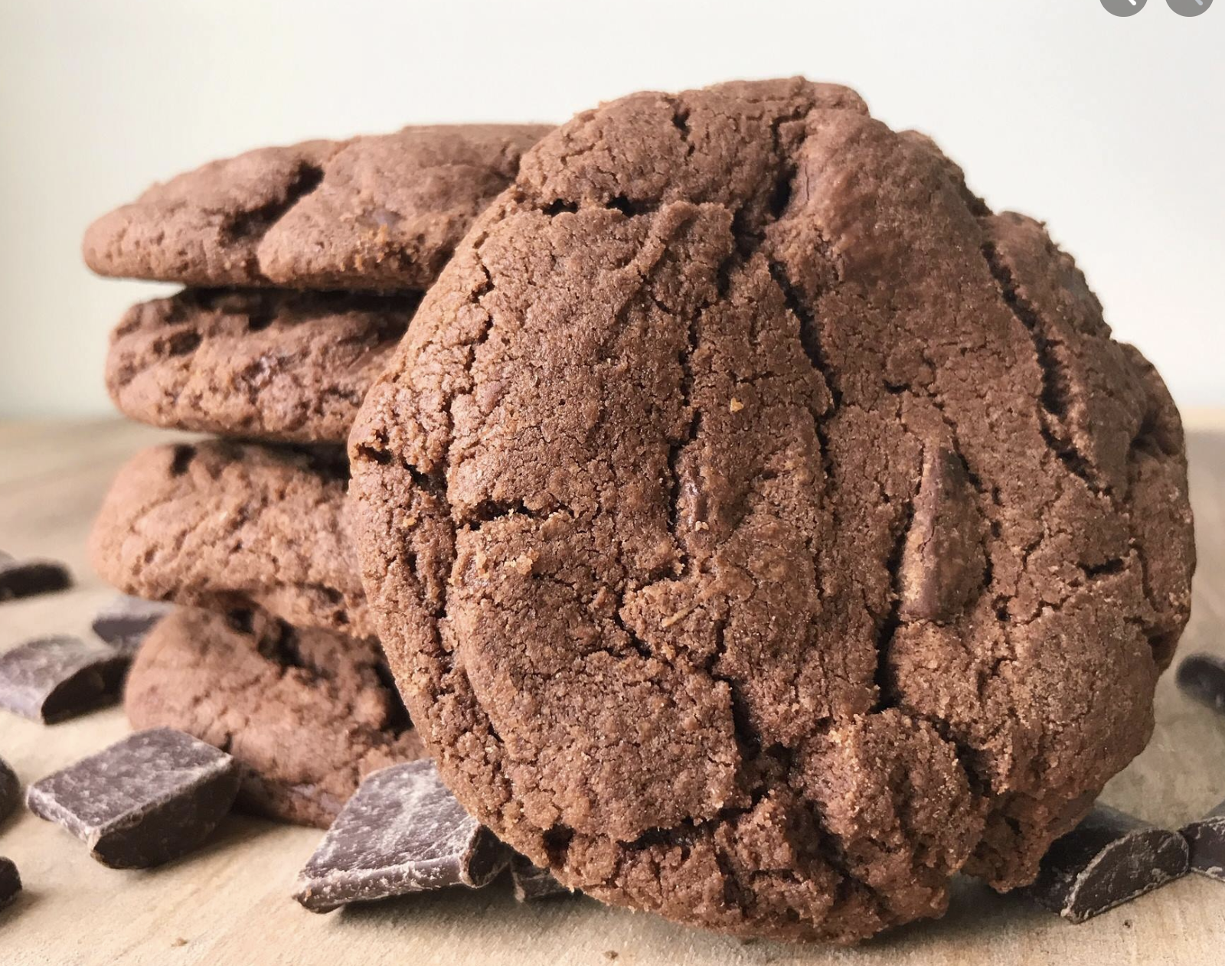
13. double_chocolate_cookies.png
14. My daughter learned to make these cookies at a baking camp at Zingermanns and has tweaked the recipe to fit the taste buds of her siblings. They are extremely sugary so the salt helps to balance it. Note, these cookies are best eaten very quickly.
15. **Recipe Ingredients** 
    1. Unsalted butter
    2. Granulated Sugar
    3. Packed light or dark brown sugar
    4. Large egg
    5. Pure vanilla extract
    6. Semi-sweet chocolate chunks (melted)
    7. All-purpose flour
    8. Natural unsweetened cocoa powder
    9. Baking soda
    10. Salt
    11. Semi-sweet chocolate chunks
16. **Recipe Steps** 
    1. In a mixing bowl cream together the butter, granulated sugar, and brown sugar
    2. Add the egg and vanilla extract and beat well
    3. Add the melted chocolate
    4. In a separate bowl combine the flour, baking soda, cocoa powder and salt
    5. Combine the wet and dry ingredients
    6. Add the unmelted chocolate chunks.
    7. Form 15 cookies and place on a baking sheet.
    8. Cooke for 12 to 13 minutes at 350 degrees.
17. **Additional Food images**
18. double_chocolate_chips.png
19. A small pile of chocolate chips
20. https://images.immediate.co.uk/production/volatile/sites/30/2020/08/chocolate-d9ba778.jpg?quality=90&webp=true&resize=600,545
21. Chocolate melting in a boiler
22. https://upload.wikimedia.org/wikipedia/commons/8/82/Brown_sugar_examples.JPG
23. Brown sugar in three different shades of darkness
24. Colleen van Lent